Radium Sorption to Iron (hydr)oxides, Pyrite, and Montmorillonite: Implications for Mobility
Michael A. Chen and Benjamin D. Kocar*
Dept of Civil and Environmental Engineering,
Massachusetts Institute of Technology
*Corresponding author, kocar@mit.edu
Abstract
Radium (Ra) is a radioactive element commonly found within soils, sediments and natural waters. Elevated Ra activities arising through natural and anthropogenic processes pose a threat to groundwater resources and human health, and Ra isotope ratios are used to decipher groundwater movement, estimate submarine discharge flux, and fingerprint contamination associated with hydraulic fracturing operations. Although adsorption to metal (hydr)oxides is well established as a dominant mechanism controlling Ra transport and retention, the extent of Ra sorption to other minerals and under variable environmental conditions (e.g. pH and salinity) is limited. Accordingly, we present results of sorption studies and surface complexation modeling (SCM) of Ra to ferrihydrite, goethite, montmorillonite, and pyrite, for a range of pH values and common background cations. Radium sorption to all substrates is observed under geochemical conditions considered, , but varies according to mineral, solution pH and specific competing cations. Literature defined SCMs were fitted to experimental data to match either the impact of pH or different cation(s), but those fits produced by these two methods were mismatched, suggesting that constants for these models derived from laboratory studies will not easily predict the transport of Ra in natural environments. Nevertheless, SCM results provide a quantitative comparison between Ra adsorption to different soil and aquifer minerals and under varying geochemical conditions, and suggest that typical means of describing and predicting Ra transport (i.e. Kd) may not be sufficient to explain and predict spatio-temporal distributions of Ra in subsurface environments.

Table of Contents (TOC) /Abstract Art

Introduction
Chronic ingestion and inhalation of radioactive materials, including radium (Ra) and radon (Rd), represents an ongoing threat to human health worldwide.¹ Of these, Ra is ubiquitous in soils, aquifers, and natural waters owing to the radioactive decay of primordial ²³⁵U, ²³⁸U, and ²³²Th, and often accounts for the dominant fraction of total radiation found in groundwater. All isotopes of Ra are unstable, and four (²²³Ra, ²²⁴Ra, ²²⁶Ra, and ²²⁸Ra) possess half-lives sufficient to persist within environmental systems and present a risk for human exposure. Moreover, ²²⁶Ra (half-life of 1600 years) is the parent radionuclide of ²²²Rn; chronic inhalation of ²²²Rn increases risk of lung cancer. Hence, geochemical controls on Ra mobility are directly tied to the mobility and accumulation of Rn within soil-sedimentary systems.²
Several geochemical processes impart overarching controls on Ra within soils and aquifers. Alpha-recoil, the ejection of daughter radionuclides from soil and sedimentary minerals into adjacent porewater, is the primary process sourcing Ra to groundwater. Ongoing alpha recoil progressively elevates porewater Ra activities until hydrologic flushing removes the equilibrating solution, or Ra achieves secular equilibrium with its parent radionuclides. Most aquifer systems contain low (e.g. U, Th, <5 mg/kg) but adequate parent radionuclide and sufficiently favorable hydrological conditions to facilitate delivery of measurable Ra to solution.³ In a recent USGS study, 3% of groundwater samples (n=1270) within 7 of 15 principal US aquifers exceeded the USEPA limit for total Ra of 0.185 Bq/L.⁴ Further, high levels of Ra are often present with deeper formations, particularly shales, where low groundwater flux yield potentially hazardous activities (0.102-343 Bq/L).⁵ These naturally elevated Ra bearing formations are prevalent in some parts of the US (PA, WY, TX) and abroad (Middle East, etc.). ^{6,7} Anthropogenic activities, including uranium mining and hydraulic fracturing, can redistribute Ra and other constituents of naturally occurring radioactive materials (NORM), posing potential hazards to populations local to affected soils, surface waters, and aquifers.
Under environmental conditions, Ra is not redox active, and its solution speciation is dominated by free Ra²⁺_{(aq)} across a wide range of chemical conditions (e.g. pH and salinity). Weak complexes with carbonate, sulfate, and chloride are observed, but these solution species are only important at extremely acidic or basic pH values and when ligand activities exceed environmentally relevant activities.¹⁰ The Ra²⁺ ion participates in several geochemical reactions that constrain (or enhance) its presence in natural waters, resulting in non-conservative transport in aquifers. Sorption to soil and aquifer solids is generally regarded as the dominant process controlling Ra solubility of in many soil and groundwater systems.^{8,9} Alternatively, co-precipitation of Ra with Ba and Sr sulfates may rapidly scavenge Ra from solution, but depends on elevated (~1 mM) levels of Ba, Sr, and SO₄²⁻ to proceed, and may be kinetically limited in natural waters.¹
Soil and sedimentary minerals known to sorb appreciable quantities of Ra include metal (hydr)oxides and 2:1 clays with an exchangeable interlayer. However, previous data are primarily derived from Ra sorption experiments using mineralogically heterogeneous soil and sedimentary solids, and fewer studies have examined Ra sorption to single minerals with simple electrolyte solutions. This has generated a wealth of reported K_{d} values for Ra sorption to different soil and aquifer materials. However, these are of limited use for deciphering the importance of specific minerals with respect to Ra sorption, and under variable conditions, including the presence of several competing cations. It is well established that increasing ionic strength will drive release of sorbed Ra into solution, but there are few studies that examine the impact of specific cations on this release.¹¹ Moreover, few studies have examined or considered mechanisms of Ra sorption; one study used surface complexation modeling (SCM) to examine Ra adsorption to metal (hydr)oxides, but at levels far exceeding those found in most environmental systems, and was limited to Fe (hydr)oxides (goethite and ferrihydrite).^{12,13} There is also a paucity of data regarding Ra adsorption to redox-sensitive minerals found under suboxic or reducing conditions. These solids, including metal sulfides such as pyrite, may be particularly important within soil and aquifer systems derived from shale, and also within marine sediments—including those which intercept submarine groundwater discharge that carry naturally occurring Ra.
Improved knowledge of Ra sorption to common soil and sedimentary solids and with different background solutions is required to decipher and predict Ra mobility and total activities within natural waters, and may aid in interpreting Ra isotopic ratios used to trace sources of Ra and understand groundwater movement. The objectives of this study were to therefore: 1) examine and compare low-activity Ra adsorption to ferrihydrite, goethite, and Na-montmorillonite—minerals known or inferred to control Ra transport over a range of solution conditions found in soils and aquifers—and pyrite, a mineral commonly found within reduced and anoxic soils and sediments, 2) examine the impact of individual and mixtures of cations on Ra sorption, and 3) evaluate the accuracy of common metal ion SCMs for predicting Ra sorption to these materials for differing solution conditions, and use SCM as a quantitative means for comparing the extent of Ra adsorption to different minerals and geochemical conditions. Generally, we find the greatest extent of Ra sorption to occur with sodium montmorillonite at low ionic strength and over a wide range of pH values. However, Ra sorption to Na-montmorillonite is extremely sensitive to both total ionic strength, and specific cations in solution with Ra. In contrast, pH controls sorption iron (hydr)oxides, with increasing pH enhancing sorption, but background cations do not affect Ra sorption as strongly as with sodium montmorillonite. Appreciable quantities of Ra sorb to pyrite over all tested solution conditions, and exhibited minimal sensitivity to solution composition, with the exception of treatments using high ionic strength solutions. Lastly, we find that common SCM thermodynamic constants are useful for providing a quantitative comparison of Ra sorption to different minerals under similar geochemical conditions, but are poor predictors of Ra adsorption when conditions (e.g. pH, ionic strength) are altered.

Materials and Methods
Dissolved ²²⁶Ra stock in 3% HCl was provided by the MIT Environmental, Health, and Safety office and used for all experiments. A ferrihydrite slurry and goethite powder were prepared using standard methods and added to the experiments.¹⁴ Powdered calcium montmorillonite STX-1b was ordered from the clay minerals society (clays.org), re-equilibrated with sodium chloride to allow for closer comparisons to previous studies of Ra sorption to Na-montmorillonites, and then cleaned of carbonates using standardized techniques.¹⁵ Pyrite was ordered from Ward’s Science (www.wardsci.com), ground using mortar and pestle, passed through sieves to select for 45-250 µm particles, and transferred to an anaerobic glove bag (2% H₂: 98% N₂: < 1 ppm O₂). It was then washed in 6 N HCl overnight to dissolve any oxidized coatings, rinsed with deoxygenated DI water three times to remove residual acid, and dried anaerobically at room temperature. The composition of pyrite, ferrihydrite and goethite was confirmed using XRD, and surface area was measured for all minerals using BET (table S1). Further information regarding mineral preparation is found in the supporting information.
All experiments were conducted using serum vials (200 mL) filled with 100 mL of background solution, 30 mg of a single mineral (except for the case of pyrite, where 40 mg was used), and 3-320 Bq of ²²⁶Ra stock. Isotherms were performed at pH 3, 5, 7, or 9 +/- 0.05 using 10 mM NaCl stock as the background solution. The impact of different background cations on Ra adsorption to xxx minerals was elucidated at pH 7 +/- 0.05 using 10 mM CaCl₂, MgCl₂, KCl, SrCl_{2,} or an 10 meq/L ionic strength artificial groundwater (AGW) (table S2). The impact of increasing ionic strength was examined with a pH 7 +/- 0.05 100 meq/L artificial brackish water (ABW) and 800 meq/L artificial seawater (ASW) (table S2). Experiments using pyrite were performed in a sub-oxic (<1 ppm O₂) glove bag, and all solutions were purged with N₂ prior to placement in the anaerobic chamber. For all experiments, an auto-titrator was used to assist pH adjustment, and bottles were sealed with a thick butyl stopper. Bottles were shaken for 24 hours to allow sufficient time for sorption equilibrium.¹² A kinetic study of Ra adsorption to montmorillonite confirmed 24 hours is sufficient to achieve equilibrium (SI). pH was readjusted after equilibration if necessary; details on this process are in the supporting information. Acid (HCl) and base (NaOH) volume additions did not exceed 5% of the original solution-slurry volume. Once re-titration and re-equilibration were complete, samples were filtered using 0.22 µm PES filters, which did not sorb significant quantities of Ra. Experimental error was quantified by measuring the standard deviation of triplicates for each data point.
Analytical Techniques. Solutions of Ra were quantified using scintillation counting. Up to 10 mL of sample were mixed with 10 mL of Ultima Gold XR (Perkin Elmer) and sealed for 30 days to allow ²²⁶Ra to reach secular equilibrium with its daughter products. The equilibrated samples were then counted using a Beckman Coulter LS 6500 scintillation counter, and the resulting counts were compared to a calibration curve of similarly prepared ²²⁶Ra standards (see SI) to determine solution activities.
Surface Complexation Modeling.
Radium interaction with mineral surfaces was modeled through mineral specific surface complexation models implemented in PHREEQC.¹⁶ The IPHREEQC COM module was used in conjunction with a python script to easily enable multiple realizations of the SCM for fitting. Reaction formulations used in previous studies were used to fit experimental data, and were supplemented with adsorption reactions for competing ions.^{12,17–19} Model fits to data were achieved through varying the thermodynamic constant for each (ad)sorption reaction. Fitting was performed on isotherm data and data from experiments testing the effects of competing cations on Ra sorption; thermodynamic constants developed for each set of experiments were then for consiste. Details for fitting SCMs here along with alternative modeling strategies are found in the supporting information.
Results and Discussion
Sorption isotherms. All isotherms using 10 mM NaCl were linear in the range of activities considered (figure S1), and thus each were fitted to a line using a least squares method, whose slope corresponds to the (mass normalized) K_{d} for that isotherm (figure 1a). Sorption to both iron (hydr)oxides show a strong dependence on pH, with ferrihydrite showing greater sorption across all pH values compared to goethite, and the extent of sorption increasing with increasing pH for both iron (hydr)oxides. Differences in the surface area (table S1) may explain some of the variation when comparing the extent of Ra sorption for goethite and ferrihydrite sorption, with ferrihydrite having nearly twice the surface area of goethite. Accordingly, the fitted K_{d} values are normalized by the measured surface area to derive a K_{sa} (figure 1b). At circumneutral pH, goethite and ferrihydrite have close K_{sa} values, however, at more extreme values (pH = 3 and pH = 9) ferrihydrite demonstrates an appreciably larger extent of sorption compared to goethite. While it is unclear why this discrepancy exists, it may arise through differences in surface chemistry and electrostatics. For example….(I believe Sanjit also attempted to explain similar differences…I’d check their paper. I think you’ll need to provide at least some kind of explanation based on differences in mineralogy)at. suggeing at differences not easily explained by these batch measurements. Two studies report isotherm data for Ra sorption to ferrihydrite.^{11,12} The K_{d} found in our study is the larger than found in those studies by at lea factor of 2 (SI for values), but was also performed at lower background ionic strength (here, 10 mM NaCl, others, 100-500 mM) and higher mineral surface area (here, 382.9 m²/g, others, ~250 m²/g).⁹ K_{sa} values were fairly close to those reported in other studies, with differences in background solution ionic strength matching with decreases in K_{sa}.
K_{d} and K_{sa} results for Ra onto sodium montmorillonite are plotted in figures 1 and 2. With the exception of ferrihydrite at pH 9, the total extent of sorption to montmorillonite is larger than iron (hydr)oxides over all pH values normalized either to mass or surface area. Also, a comparatively weaker pH dependence is observed for montmorillonite sorption. This result implies that the dominant mechanism controlling montmorillonite sorption is not complexation with pH dependent surface (edge) functional groups, but rather exchange of Ra with clay interlayer cations. Unlike with the iron (hydr)oxides, near order of magnitude differences in K_{d} and K_{sa} were found when comparing to other studies, in spite of similar background solution composition.^{15,20} Those used a high solid-solution ratio (3000-50000 mg solid/L) but resulted in less sorption compared to the sorption results found here, which used only a 300 mg/L solid-solution ratio.^{15,21} The CEC of the montmorillonites used in those works are also similar to that used in this experiment (within 10 meq/100 g clay). Given the similarities in experimental conditions beyond mineral loading, it is unclear why more extensive sorption would be found here based solely on the parameters of the batch studies.
Pyrite showed low, but appreciable sorption over all pH values, but weak dependence on pH (figure 1), with similar sorption to some iron (hydr)oxides at acidic pH values. Unexpectedly, surface area normalized sorption isotherms show that pyrite has the largest sorption of all of the minerals considered here (figure 2). There is very little existing data examining the sorption of Ra to any reduced iron solid. A previous study demonstrated that strontium (Sr), which possesses analogous geochemical characteristics as Ra, did not sorb extensively to pyrite²²; In contrast, a variety of experimental and spectroscopic techniques have been used to study redox active metal ions sorption to the pyrite surface, which often includes redox reactions between the metal ion and pyrite surface groups.^{22–27} The results of these studies imply that redox active metal ions or trace quantities of dissolved oxygen in solutions with Ra may alter the pyrite surface, consequentially diminishing or enhancing Ra sorption. However, we find no evidence of (oxic) pyrite alteration in our experimentation, and use exceedingly low Ra concentrations (0.06-31 nmoles per experiment) which preclude using analytical methods for examining the coordination environment of adsorbed Ra. The difference in reported Sr sorption and Ra sorption may instead by driven by natural pyrite impurities, but it is unclear from measurements made here. Further study of the pyrite surface in anoxic and suboxic settings is necessary to constrain pyrite’s control on Ra transport. Authigenic pyrite found in natural shales and estuarine settings may show enhanced sorption compared to that found here, as they may have larger surface area than the crushed pyrite here.
Background cation controls on Ra sorption
Experiments using different background electrolytes, but with similar ionic strength, initial concentration of Ra (60-70 Bq total activity) and pH (7.0) illustrate notable deviations from Ra adsorption trends observed using NaCl (Figure 2). In particular, sodium montmorillonite which shows large changes in Ra retention in the presence of different competing cations. Notably, the use of a low ionic strength artificial groundwater altered trends originally observed for Ra isotherms using a xxx mM NaCl background, with ferrihydrite having a larger sorption extent compared to the montmorillonite. This is likely a result of competition for exchange sites in the clay, which were not present in the iron oxides. Divalent cations tended to reduce Ra sorption compared to monovalent cations, as did heavier ions, with strontium having minimal sorption across all minerals. Pyrite showed little sensitivity to cation type. The artificial groundwater results suggest that Ra transport is generally enhanced compared to what has been found in experimental studies, which have primarily focused on sodium as the only background cation. Overall, less adsorption of Ra is to all substrates is observed in experiments in which artificial groundwater is used; hence, sorption data from experiments using background solutions dominated by a single monovalent cation such as sodium may overestimate the extent of Ra sorption compared to natural solutions harboring a diversity of mono and multi-valent cations. Additionally, the results here suggest that shifts in groundwater ion composition may drive shifts in Ra retention depending on the composition of the resulting pore water. This is particularly relevant for hydraulic fracturing systems where injected groundwaters tend to have a different ionic composition compared to the natural formation brine, and could be tuned to reduce Ra concentrations in the resulting produced water.
Experiments to examine the influence of increasing ionic strength were also performed, using the same ratio of cations used in the artificial groundwater, but with increasing total ionic strength (figure 3). Specifically, “brackish” (100 meq/L) and “seawater” (800 meq/L) ionic strengths were targeted (pH 7.0) . As with experiments using different electrolyte compositions, the greatest decrease in Ra adsorption occurred in treatments using sodium montmorillonite, xxx percent less sorption occurred than in 10 mM NaCl. In contrast, high ionic strength solutions imparted less affect on Ra adsorption to Fe (hydr)oxides—only xxx% and xxx% less sorption to goethite and ferrihydrite occurred in seawater, respectively. These results illustrate that clays possessing an exchangeable interlayer harbor appreciable Ra under low ionic strength conditions, but iron (hydr)oxides may control radium sorption across shifting solution conditions such as those found within intertidal zones, etc. Nevertheless, all minerals experienced decreases in Ra sorption with increasing ionic strength, suggesting the increased presence of competing cations will reduce Ra sorption overall, even at trace levels. This is consistent with previous studies of Ra sorption in saline conditions, which also found similar results for iron (hydr)oxide phases.¹¹ However, it is important to note that some Ra is still retained by these surfaces under high ionic strength conditions, suggesting that soil-sedimentary solids may serve as persistent sources or sinks of Ra despite large shifts in solution composition.
Surface Complexation Modeling.
The naturally low levels of Ra in the environment combined with the significant radiotoxicity of Ra have hindered the development of spectroscopically informed models of Ra-specific SCM’s. In light of this, the surface reactions used in SCM fitting were drawn from specific models already established in the literature, and only intrinsic reaction constant values relevant to Ra surface complexes were fit to attempt to match experimental results found here. Reaction constants for competing background cations were sourced from either reported values in the literature or derived by linear free energy relationships posed in the literature (SI for values). In all cases, a double diffuse layer formulation is used for SCM, following Dzombak and Morel’s generalized two layer mode.¹⁷ For the iron (hydr)oxides, Ra2+ adsorption is simulated through interaction with strong and weak sites, and multiple surface reactions, while sodium montmorillonite was fitted using a non-electrostatic model using an exchange reaction, strong surface site, and weak surface site using a similar approach as Baeyens and Bradbury. ¹⁷ ¹⁸ ²⁸ Attempts to model Ra2+ adsorption to pyrite were unsuccessful using the double layer approach with inferred pyrite surface functional groups (ref) nor a model simulating both oxidized and non-oxidized surface sites, suggesting that further investigation of pyrite/Ra surface complexation is necessary to build modeling capability.²² The isotherm data and varied background solution data were fit independently of each other, and the resulting fits cross checked against the other data set to examine the predictive power of these models.
For ferrihydrite and goethite, fits of isotherm data to the SCM (see table 1 for Ra surface complexes considered and SI for the full set of reactions considered) produced good visual fits. When these log K values were used in solutions with different background compositions, the fits were also reasonable (root mean squared error (RMSE) of Ra fraction sorbed: 0.31 and 0.16 for ferrihydrite and goethite respectively), but were numerically improved through iterative fitting (RMSE: 0.16 and 0.10) (table 1), whose log K values also produced a reasonable, but worse visual fit for the isotherm data. While the fits are reasonable, the corresponding log K values varied at least by 1 log unit, and often many more, suggesting the model fits have only limited predictive power when extended to natural background solutions and minerals.
Surface complexation modeling of Ra sorption to montmorillonite was achieved through inclusion of an inter-layer exchange reaction, which was necessary to reproduce the high amount of Ra sorption observed at low pH values. However, Ra sorption is over predicted when using literature selectivity coefficients, as they are derived for trace level cation activities below those used in experiments here. Nevertheless, removal of these selectivity coefficients does not improve the fits however, as the model then overpredicts (underpredicts???) Ra sorption.
Implications for radium mobility in soils, sediments and aquifers
Results presented here illustrate the dominant role of mineralogy on the retention, release, and transport of Ra in soil and sedimentary systems. Poorly crystalline iron (hydr)oxides (e.g. ferrihydrite) will act as greater Ra sorbent than goethite within variably saturated soils and sediments, whereas pyrite may retain Ra within deep shale aquifers or permanently anoxic freshwater and sediments. Under fixed, circumneutral pH and background electrolyte composition, the extent of Ra sorption to each mineral is appreciably different, hence mineralogical transformation through processes including Ostwald ripening (e.g. ferrihydrite transformation to goethite) or reduction-oxidation (pyrite oxidation to secondary iron (hydr)oxides)) are expected alter Ra mobility and fate. Moreover, variation in solution chemistry alter observed Ra sorption trends differently for each mineral, likely reflecting known or inferred mechanisms of Ra-solid association. For example, sodium montmorillonite retains more Ra than ferrihydrite under low-ionic strength and pH conditions, but this trend is reversed with increased activity of divalent cations that compete with Ra for interlayer sites through mass action (and greater selectivity relative to monovalent cations) compared to competition with Ra complexed with ferrihydrite surface sites. These mechanisms are partially validated through SCM, which are used to successfully describe Ra sorption to Fe (hydr)oxide surfaces and sodium montmorillonite edge and inter-layer sites, and which also provide a means to quantitatively compare Ra sorption between minerals across a range of geochemical conditions. However, discrepancies in Log K values obtained for Ra sorption under different solution conditions, and difficulties associated with modeling Ra sorption to pyrite illustrate
that laboratory derived SCM reaction constants will not accurately describe or predict Ra sorption and reactive transport within (bio)geochemically complex systems. Further analytical investigation of Ra interactions with minerals and mineral surfaces are therefore required to improve mechanistic descriptions used in modeling efforts, particularly those used for describing Ra transport within soil and sedimentary systems with fluctuating geochemical conditions driven by tidal activity, variable groundwater flow, and the industrial extraction and processing of deep groundwater generated from hydraulic fracturing and hydrocarbon extraction operations.
Acknowledgements
The authors thank Mitch Galanek, MIT Environmental Health and Safety, for supplying ²²⁶Ra stock solutions, radiation protection equipment and safety expertise, Neha Mehta (MIT) for her assistance with scintillation/gamma counting, Tiffany Wang (MIT) for assisting with isotherm experiments, and Dara Hok of the Kim Lab (Chapman University) for performing BET analysis. This work was partially supported by the MIT energy initiative (MITEI). The authors declare no competing financial interest.

Supporting Information
Additional descriptions of methods and results are presented in supporting information.
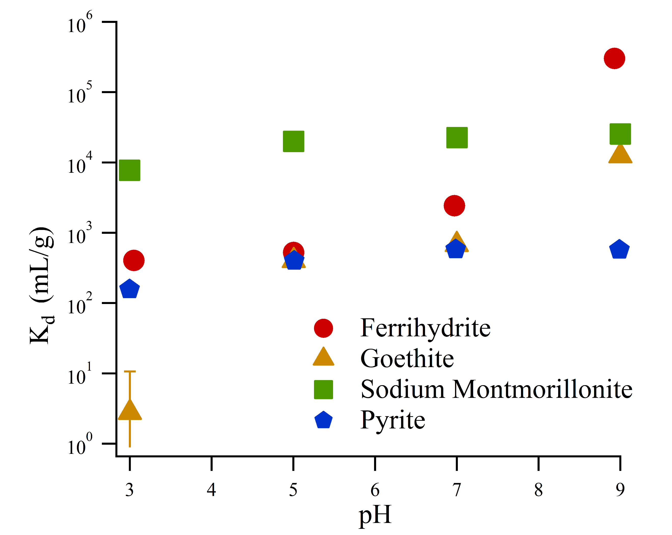
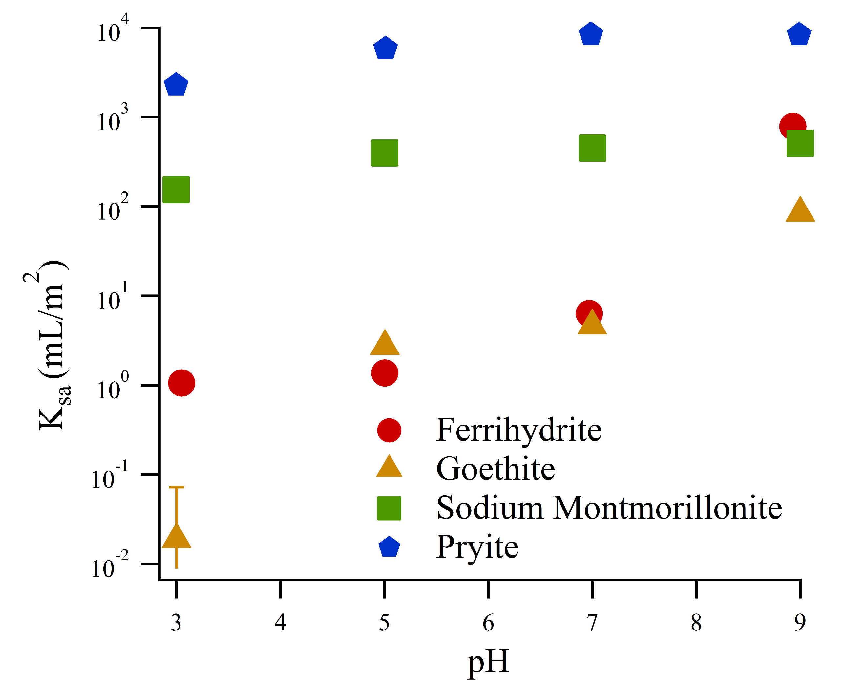

Figure 1: Sorption isotherm fits normalized by mass (left, figure 1a) or by surface area (right, figure 1b)

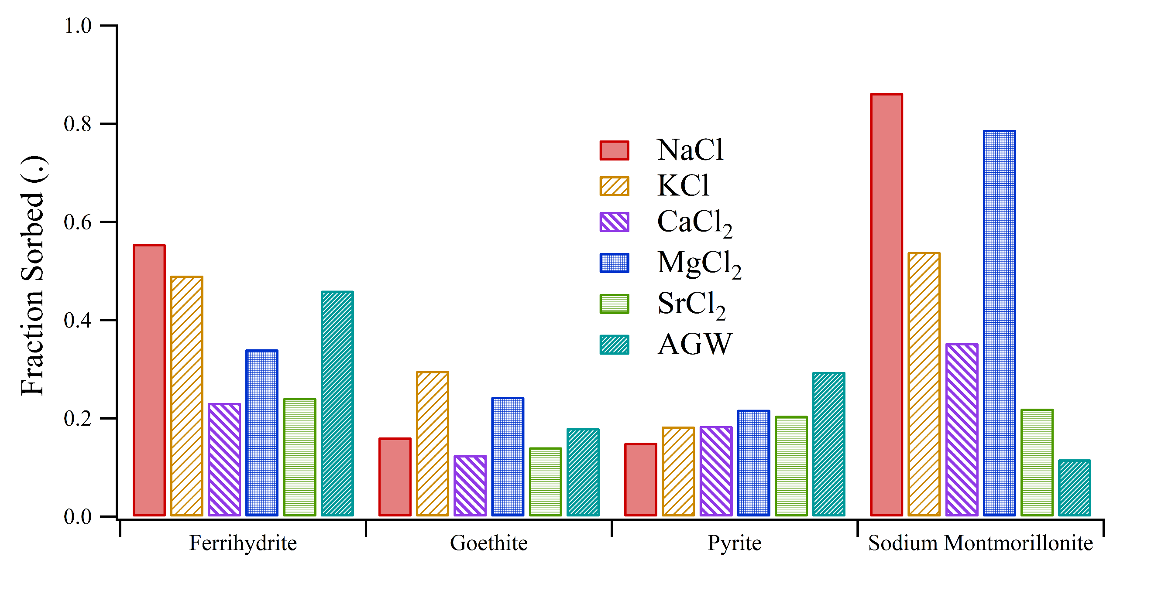
Figure 2: Impact of competing cations on Ra sorption (pH = ?, ionic strength for all solutions, I~xxx).
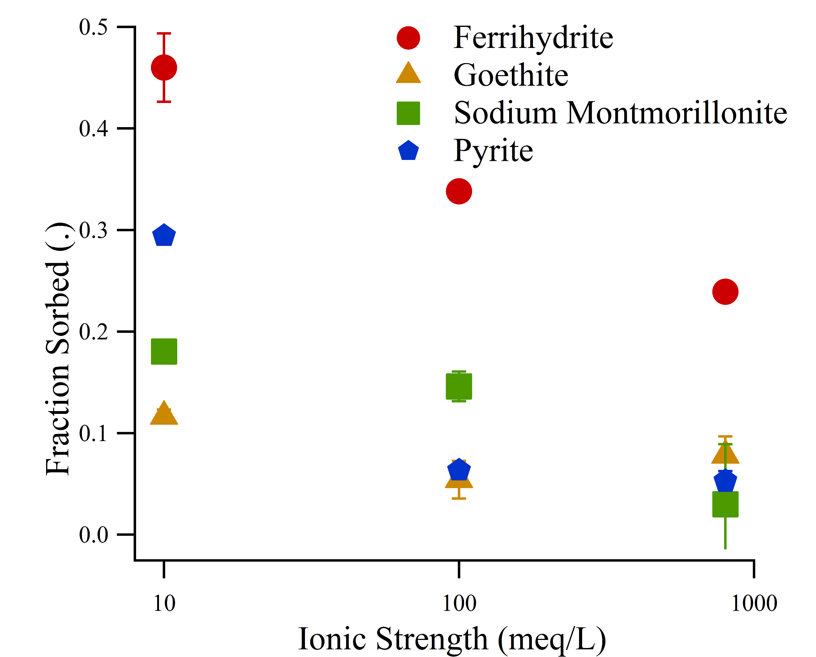
Figure 3: Impact of ionic strength on Ra sorption (mixed cation solutions, pH 7).

Author Information
Corresponding Author: Benjamin D. Kocar, 15 Vassar Street, Building 48-323. Department of Civil and Environmental Engineering, Massachusetts Institute of Technology, Cambridge, MA 02139. kocar@mit.edu. 617-324-7746

References
(1) Zhang, T.; Gregory, K.; Hammack, R. W.; Vidic, R. D. Co-precipitation of radium with barium and strontium sulfate and its impact on the fate of radium during treatment of produced water from unconventional gas extraction. Environ. Sci. Technol. 2014, 48 (8), 4596–4603 DOI: 10.1021/es405168b.
(2) Jones, A. P. Indoor air quality and health. Atmos. Environ. 1999, 33 (28), 4535–4564 DOI: 10.1016/S1352-2310(99)00272-1.
(3) Lu, N.; Mason, C. F. V. Sorption-desorption behavior of strontium-85 onto montmorillonite and silica colloids. Appl. Geochemistry 2001, 16 (14), 1653–1662 DOI: 10.1016/S0883-2927(01)00060-9.
(4) Szabo, Z.; dePaul, V. T.; Fischer, J. M.; Kraemer, T. F.; Jacobsen, E. Occurrence and geochemistry of radium in water from principal drinking-water aquifer systems of the United States. Appl. Geochemistry 2012, 27 (3), 729–752 DOI: 10.1016/j.apgeochem.2011.11.002.
(5) Barbot, E.; Vidic, N. S. N.; Gregory, K. B. K. K. B.; Vidic, R. D. R. Spatial and temporal correlation of water quality parameters of produced waters from devonian-age shale following hydraulic fracturing. Environ. Sci. Technol. 2013, 47 (6), 2562–2569 DOI: 10.1021/es304638h.
(6) Vengosh, A.; Hirschfeld, D.; Vinson, D.; Dwyer, G.; Raanan, H.; Rimawi, O.; Al-zoubi, A.; Akkawi, E.; Marie, A.; Haquin, G.; et al. High Naturally Occurring Radioactivity in Fossil Groundwater from the Middle East. Environ. Sci. Technol. 2009, 43, 1769–1775 DOI: 10.1021/es802969r.
(7) Lauer, N.; Vengosh, A. Age Dating Oil and Gas Wastewater Spills Using Radium Isotopes and Their Decay Products in Impacted Soil and Sediment. Environ. Sci. Technol. Lett. 2016, 3 (5), acs.estlett.6b00118 DOI: 10.1021/acs.estlett.6b00118.
(8) Fesenko, S.; Carvalho, F.; Martin, P.; Moore, W. S.; Yankovich, T. Radium in the Environment. The Environmental Behavior of Radium: Revised Edition. 2014, pp 33–105.
(9) Gonneea, M. E.; Morris, P. J.; Dulaiova, H.; Charette, M. a. New perspectives on radium behavior within a subterranean estuary. Mar. Chem. 2008, 109 (3–4), 250–267 DOI: 10.1016/j.marchem.2007.12.002.
(10) Grivé, M.; Duro, L.; Colàs, E.; Giffaut, E. Thermodynamic data selection applied to radionuclides and chemotoxic elements: An overview of the ThermoChimie-TDB. Appl. Geochemistry 2015, 55, 85–94 DOI: 10.1016/j.apgeochem.2014.12.017.
(11) Beck, A. J.; Cochran, M. a. Controls on solid-solution partitioning of radium in saturated marine sands. Mar. Chem. 2013, 156, 38–48 DOI: 10.1016/j.marchem.2013.01.008.
(12) Sajih, M.; Bryan, N. D. D.; Livens, F. R. R.; Vaughan, D. J. J.; Descostes, M.; Phrommavanh, V.; Nos, J.; Morris, K. Adsorption of radium and barium on goethite and ferrihydrite: A kinetic and surface complexation modelling study. Geochim. Cosmochim. Acta 2014, 146, 150–163 DOI: 10.1016/j.gca.2014.10.008.
(13) Sverjensky, D. A. Prediction of the speciation of alkaline earths adsorbed on mineral surfaces in salt solutions. Geochim. Cosmochim. Acta 2006, 70 (10), 2427–2453 DOI: 10.1016/j.gca.2006.01.006.
(14) Schwertmann, U.; Cornell, R. Iron Oxides in the Laboratary; Wiley-VCH Verlag GmbH: Weinheim, Germany, 2000.
(15) Tamamura, S.; Takada, T.; Tomita, J.; Nagao, S.; Fukushi, K.; Yamamoto, M. Salinity dependence of 226Ra adsorption on montmorillonite and kaolinite. J. Radioanal. Nucl. Chem. 2013, 299 (1), 569–575 DOI: 10.1007/s10967-013-2740-3.
(16) Parkhurst, D. L.; Appela, C. A. J. Description of Input and Examples for PHREEQC Version 3 — A Computer Program for Speciation , Batch-Reaction , One-Dimensional Transport , and Inverse Geochemical Calculations; 2013.
(17) Dzombak, D.; Morel, F. Surface Complexation Modeling: Hydrous Ferric Oxide; Wiley: New York, NY, 1990.
(18) Mathur, S. S.; Dzombak, D. A. Surface complexation modeling: Goethite; 2006; pp 443–468.
(19) Bradbury, M. H.; Baeyens, B. A mechanistic description of Ni and Zn sorption on Part II: modelling. J. Contam. Hydrol. 1997, 27, 223–248 DOI: 10.1016/S0169-7722(97)00008-9.
(20) Ames, L.; McGarrah, J.; Walker, B. Sorption of trace constituents from aqueous solutions onto secondary minerals. II. Radium. Clays Clay Miner. 1983, 31 (5), 335–342.
(21) Ames, L. L. Sorption of Trace Constituents from Aqueous Solutions onto Secondary Minerals. I. Uranium. Clays Clay Miner. 1983, 31 (5), 321–334 DOI: 10.1346/CCMN.1983.0310501.
(22) Naveau, A.; Monteil-Rivera, F.; Dumonceau, J.; Catalette, H.; Simoni, E. Sorption of Sr(II) and Eu(III) onto pyrite under different redox potential conditions. J. Colloid Interface Sci. 2006, 293 (1), 27–35 DOI: 10.1016/j.jcis.2005.06.049.
(23) Murphy, R.; Strongin, D. Surface reactivity of pyrite and related sulfides. Surf. Sci. Rep. 2009, 64 (1), 1–45 DOI: 10.1016/j.surfrep.2008.09.002.
(24) Kornicker, W. A.; Morse, J. W. Interactions of divalent cations with the surface of pyrite. Geochim. Cosmochim. Acta 1991, 55 (8), 2159–2171 DOI: 10.1016/0016-7037(91)90094-L.
(25) Wersin, P.; Hochella, M. F.; Persson, P.; Redden, G.; Leckie, J. O.; Harris, D. W. Interaction between aqueous uranium (VI) and sulfide minerals: Spectroscopic evidence for sorption and reduction. Geochim. Cosmochim. Acta 1994, 58 (13), 2829–2843 DOI: 10.1016/0016-7037(94)90117-1.
(26) Naveau, A.; Monteil-Rivera, F.; Guillon, E.; Dumonceau, J. Interactions of aqueous selenium (-II) and (IV) with metallic sulfide surfaces. Environ. Sci. Technol. 2007, 41 (15), 5376–5382 DOI: 10.1021/es0704481.
(27) Das, D. K.; Pathak, P. N.; Kumar, S.; Manchanda, V. K. Sorption behavior of Am3+ on suspended pyrite. J. Radioanal. Nucl. Chem. 2009, 281 (3), 449–455 DOI: 10.1007/s10967-009-0030-x.
(28) Bradbury, M. H.; Baeyens, B. A mechanistic description of Ni and Zn sorption on Na-montmorillonite Part II: modelling. J. Contam. Hydrol. 1997, 27 (3–4), 223–248 DOI: 10.1016/S0169-7722(97)00007-7.
(29) Bradbury, M. H.; Baeyens, B.; Geckeis, H.; Rabung, T. Sorption of Eu(III)/Cm(III) on Ca-montmorillonite and Na-illite. Part 2: Surface complexation modelling. Geochim. Cosmochim. Acta 2005, 69 (23), 5403–5412 DOI: 10.1016/j.gca.2005.06.031.

